1. Student account in 134.193.129.16 server has password: computer which is known by hydra dictionary attack.

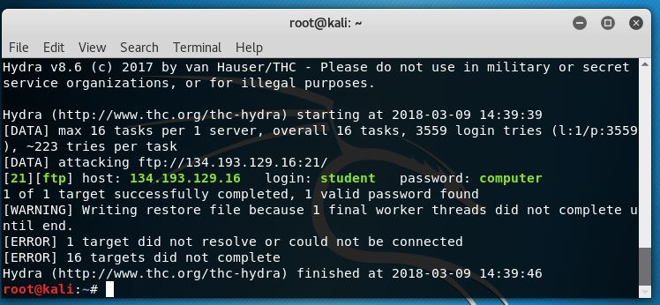

1. User login account named cs5573 is subjected to brute force attack and after 1582 attacks on the account the password is found.

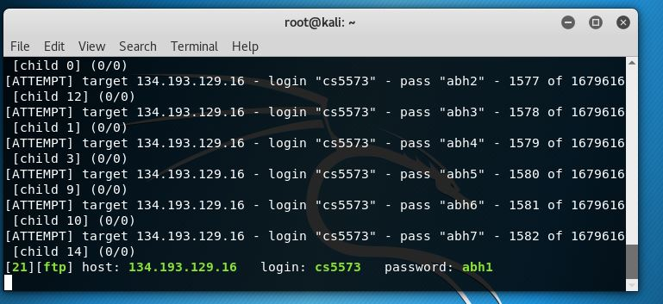

**3.**Hashing is a mathematical method to produce a fixed length encoded string for any given string. The main importance of the hashing algorithm is that it has ability to hide the original string. And also it is a one way function.

The password in the Linux are stored in the /etc/passwd file in the root directory. In linux and in windows it is stored in C:\Windows\System32\config in SAM file.

**4.**

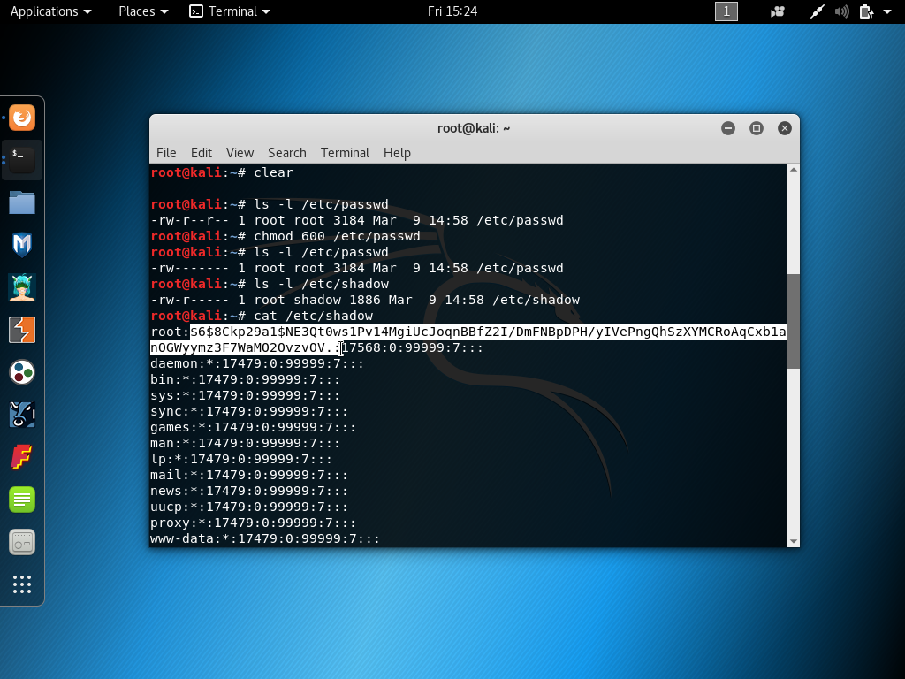

$6 represents the algorithm used in the hashing, which SHA-512 algorithm.

The salt value found for the root is shown below

The passwords in the kali Linux are stored in the **/etc/shadow** file in the root directory. This remains same for all the flavours of Linux.

**$hash algorithm version$ SALT VALUE$ SALT VALUE+ USER PASSWORD::::::: HOWLONG THE PASSWORD IS CREATED.**

The password for the other users created in my system are also displayed below and both the hash values are differed as encrypted password changes even with the change in single letter in both the passwords.

The hashed value is as follows:

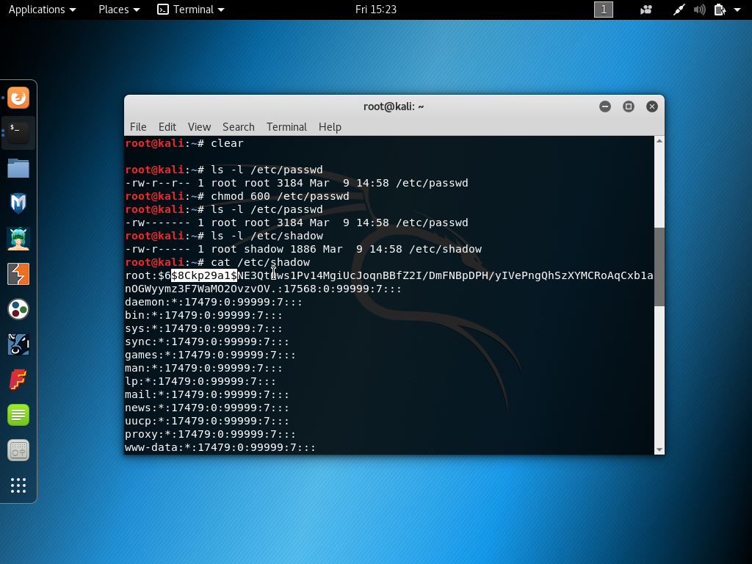

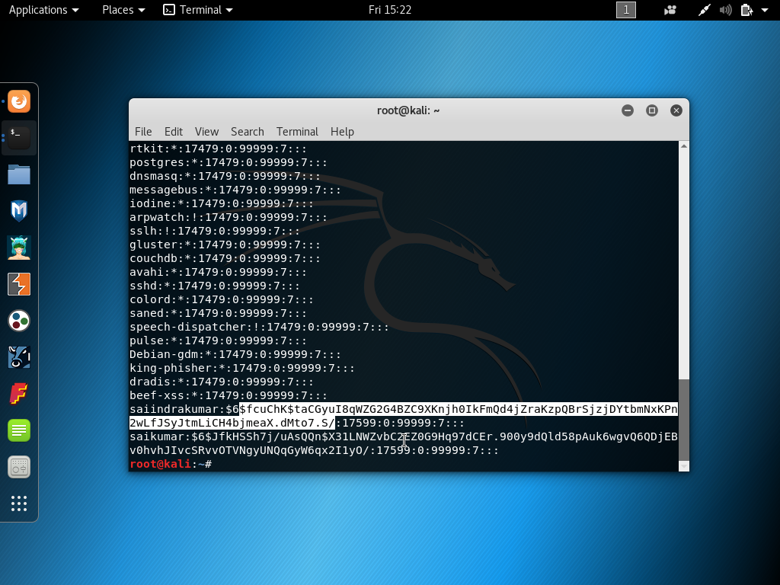

In Windows the account password is stored in SAM file in the config folder in the windows partition note that it can be accessed only when the windows is shutdown when the system is running it is unable to open.

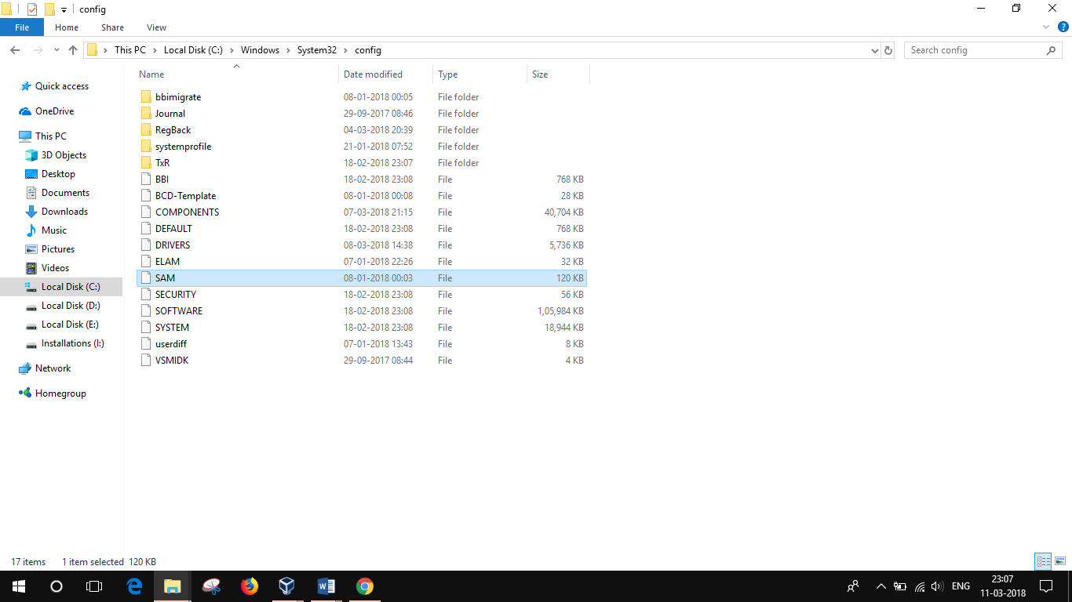

**5.**LIVE SYSTEMS of **134.193.129.16/24**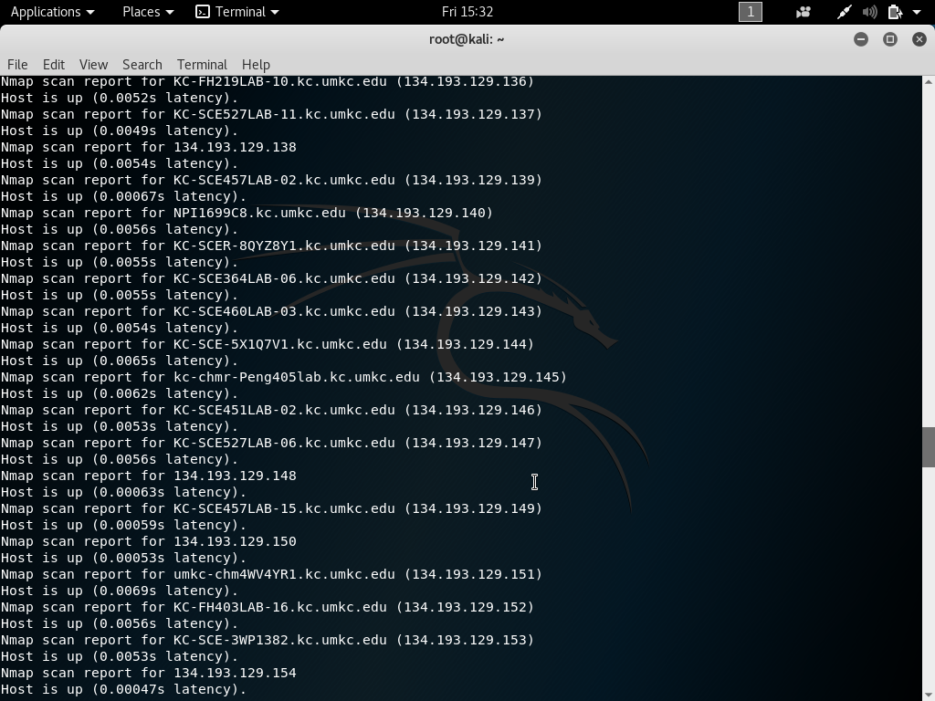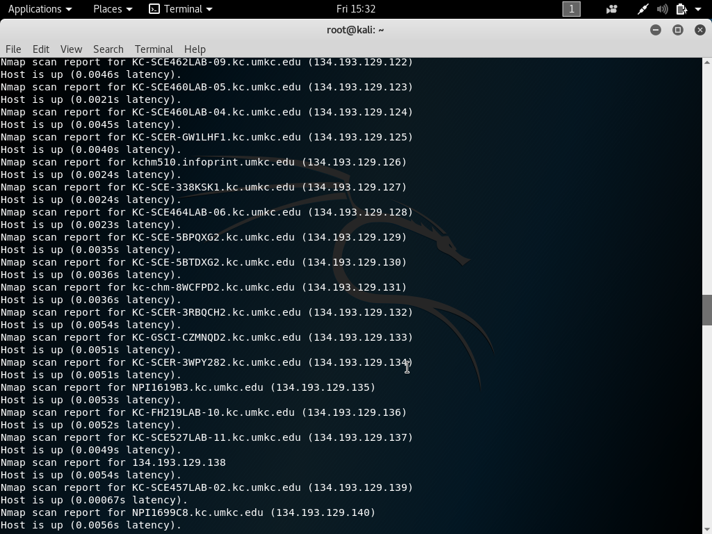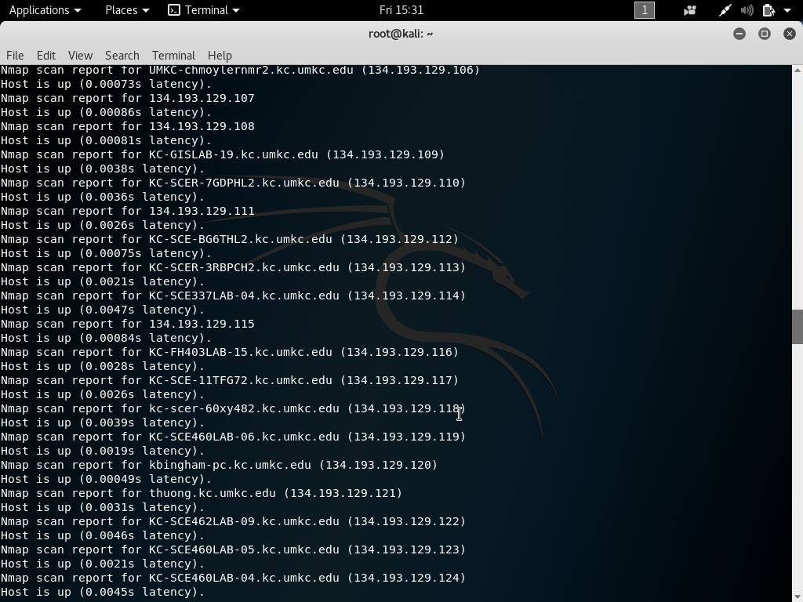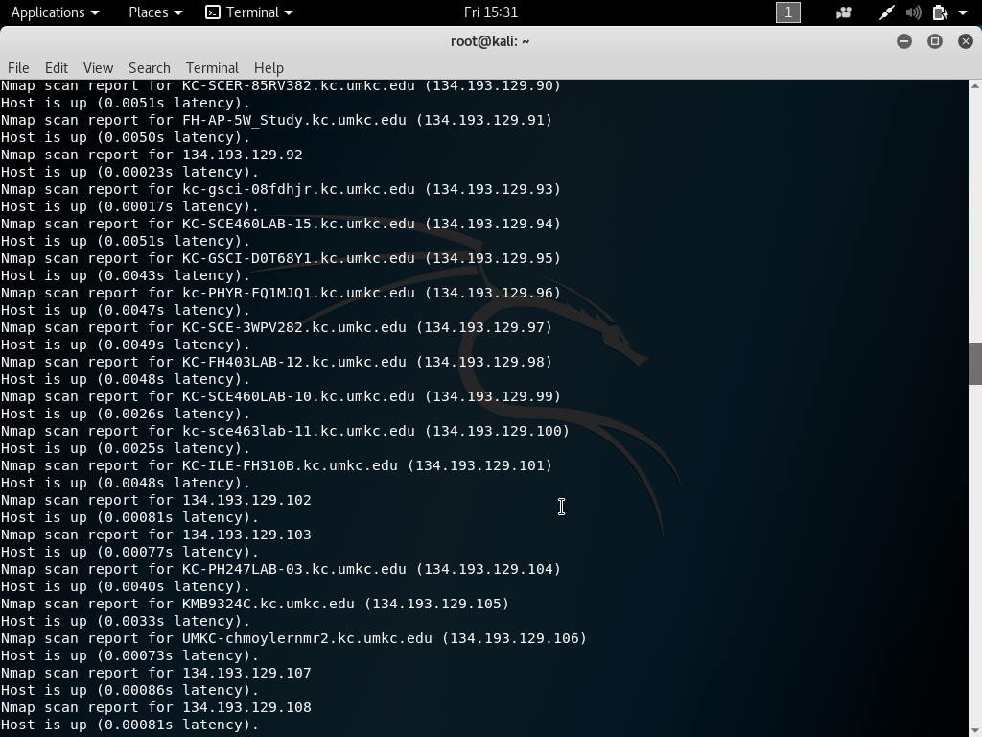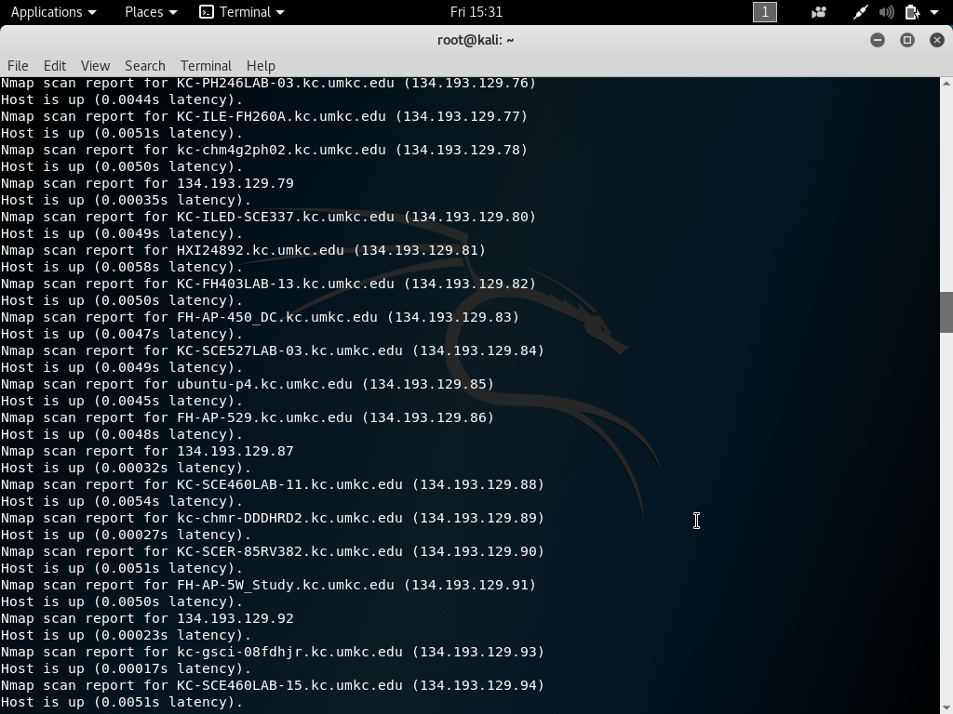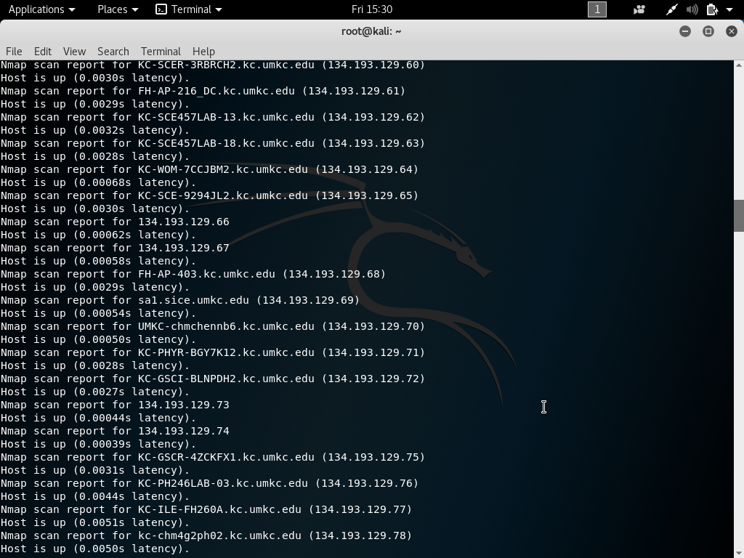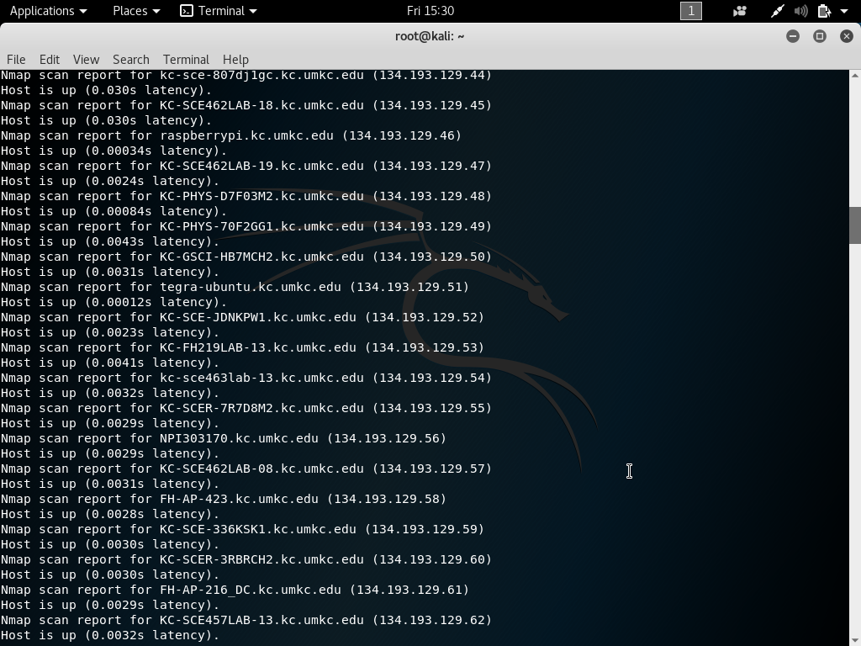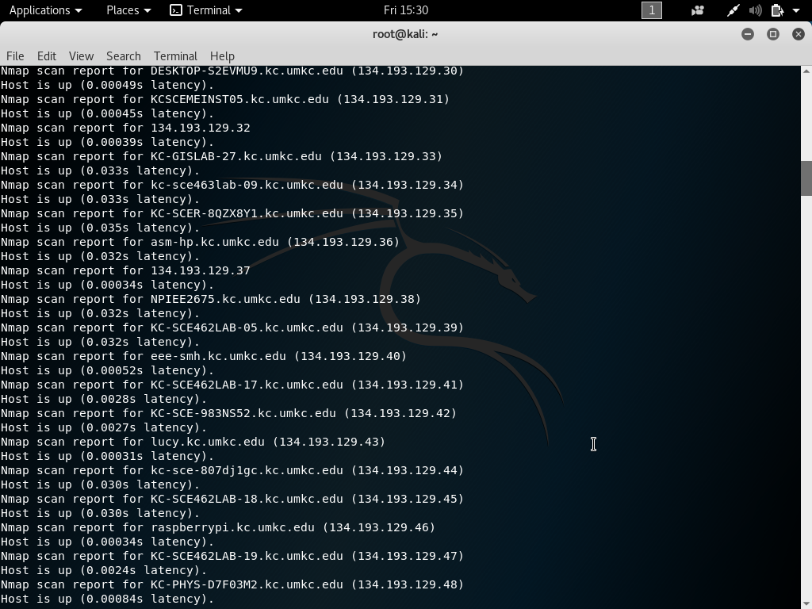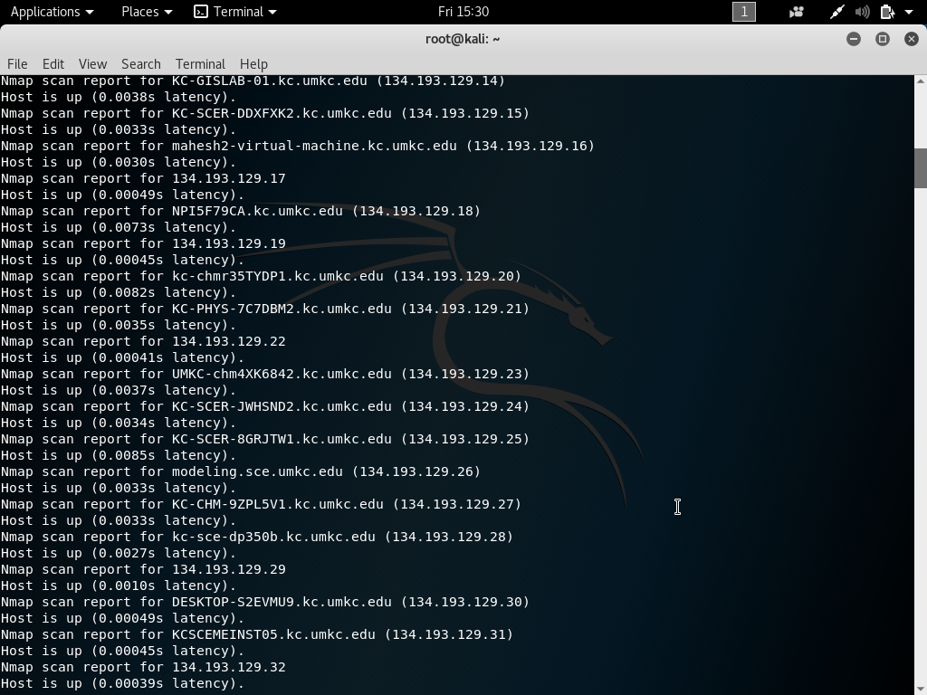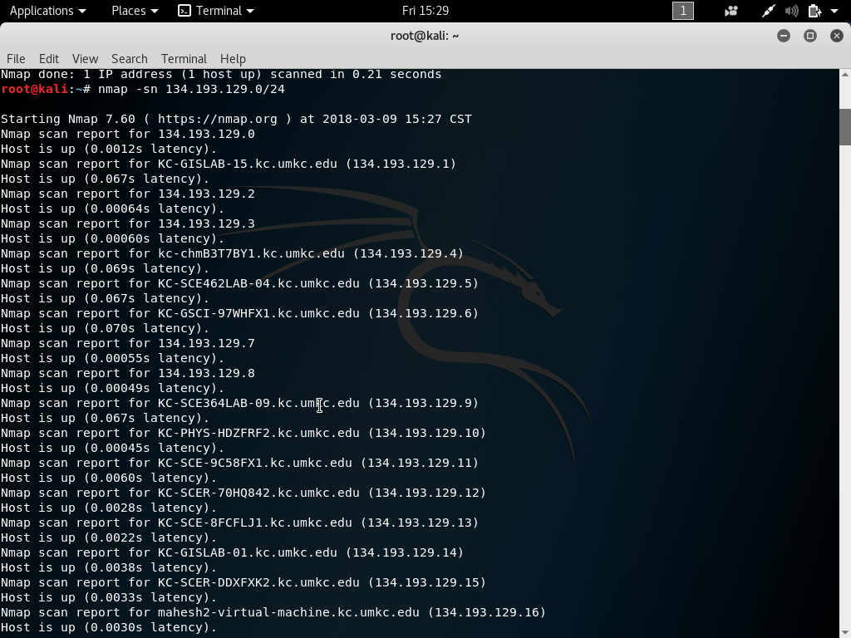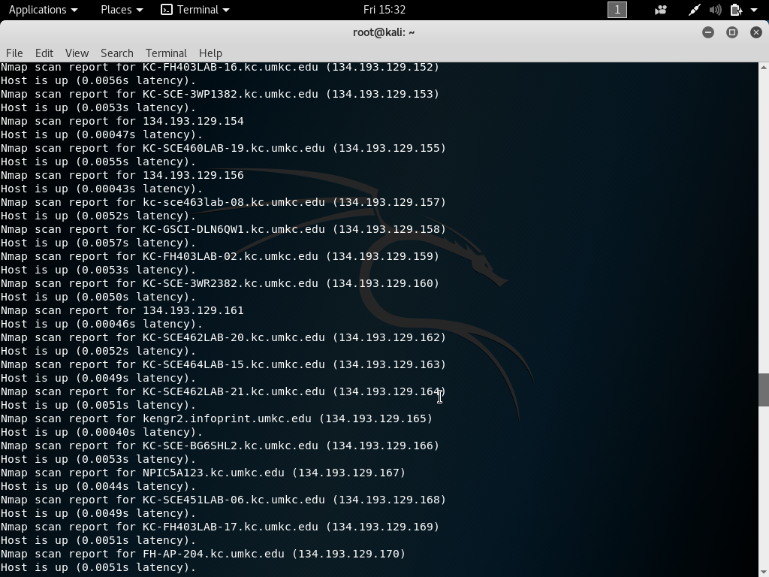

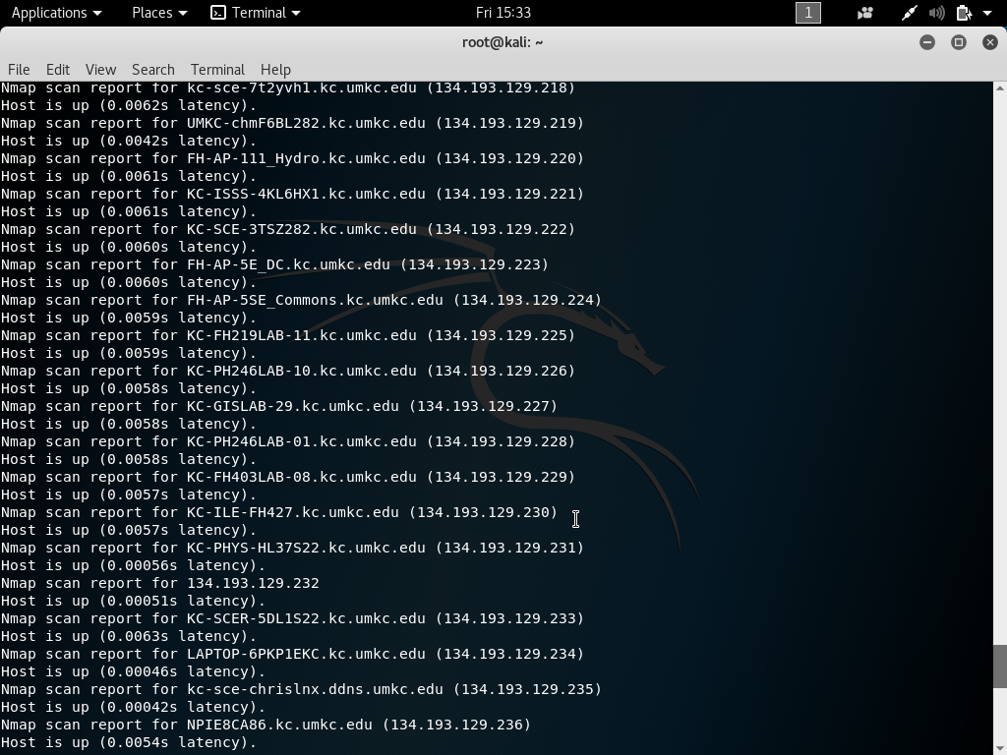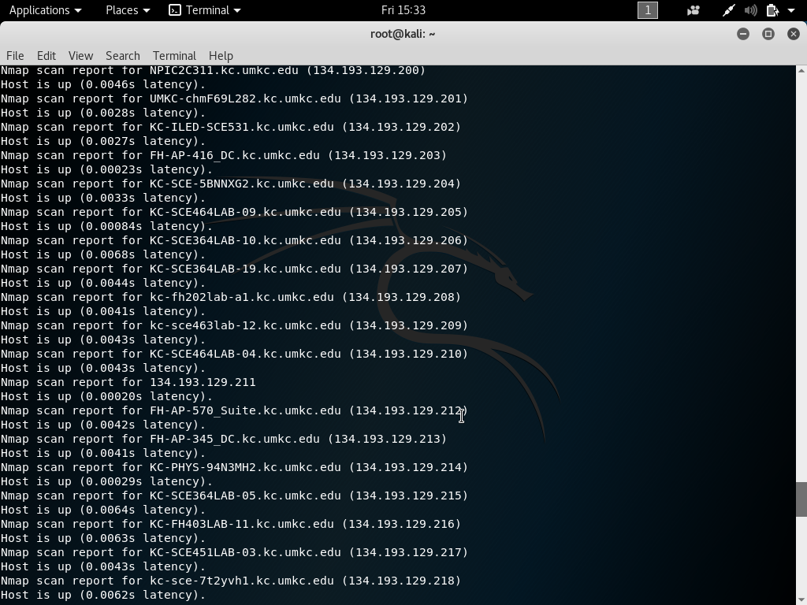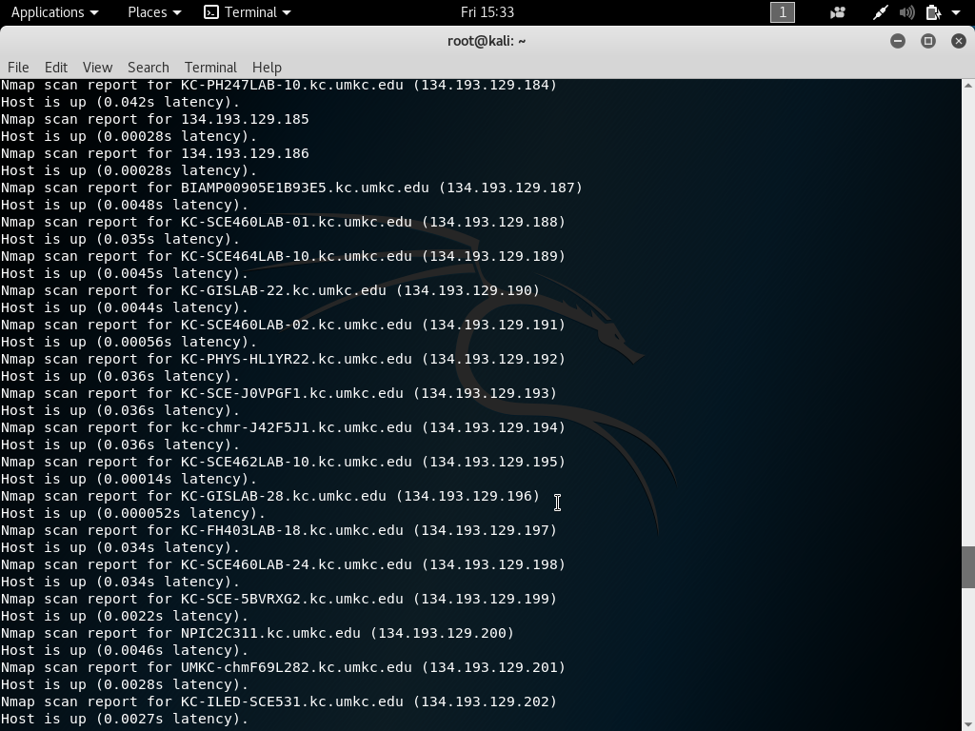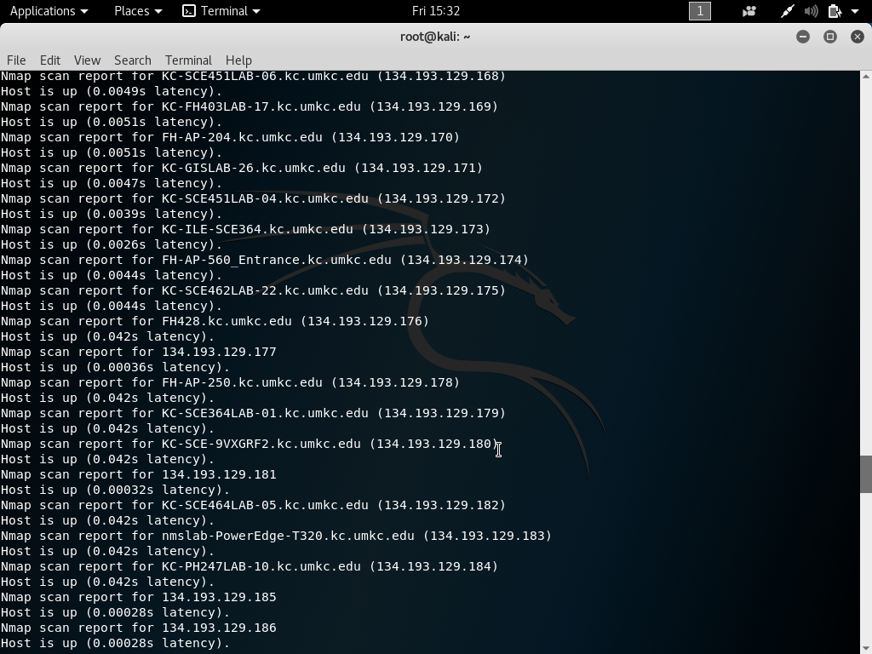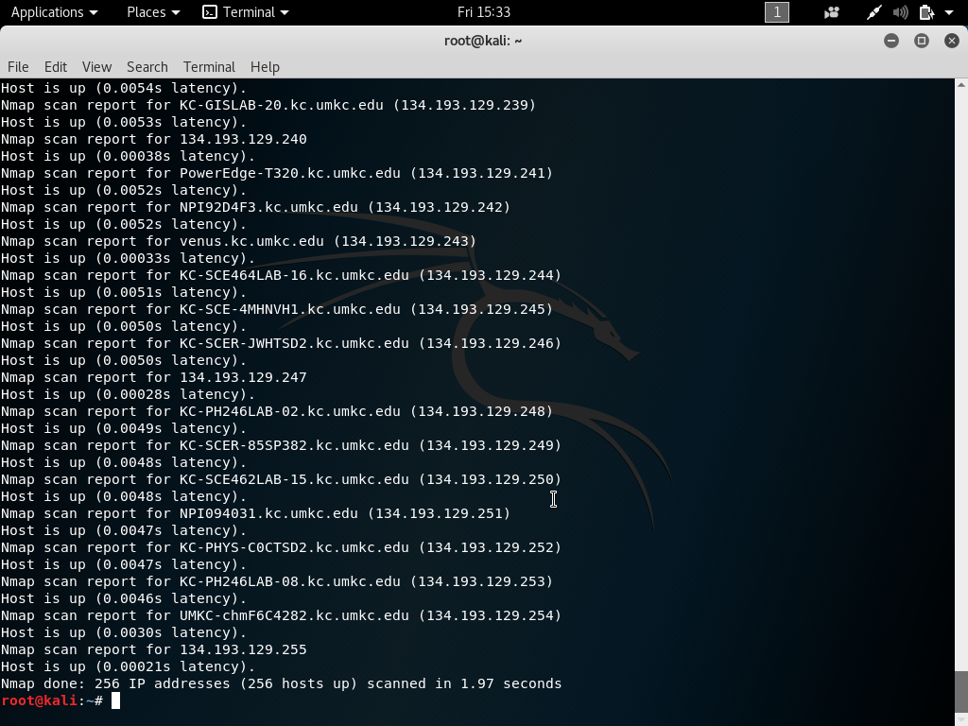

**6.** the TCP port is opened up and we came to know it by typing the command nmap -p 21 134.193.129.26 in the kalilinux terminal.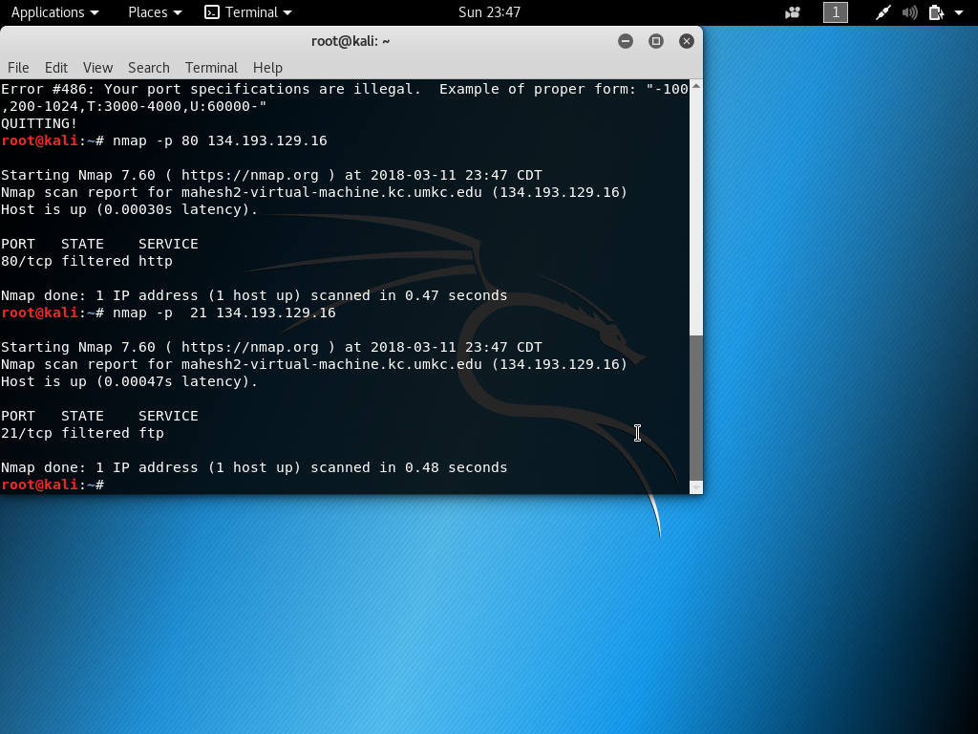

**7**.the server 134.193.129.16 is set up on the virtual machine and guessing is also performed whether it is correct or not .

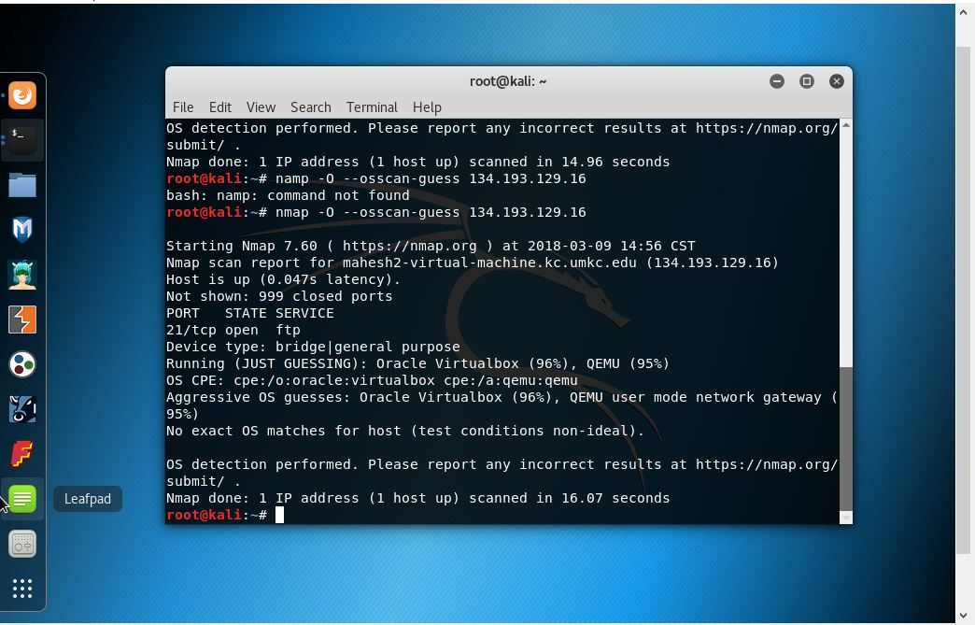

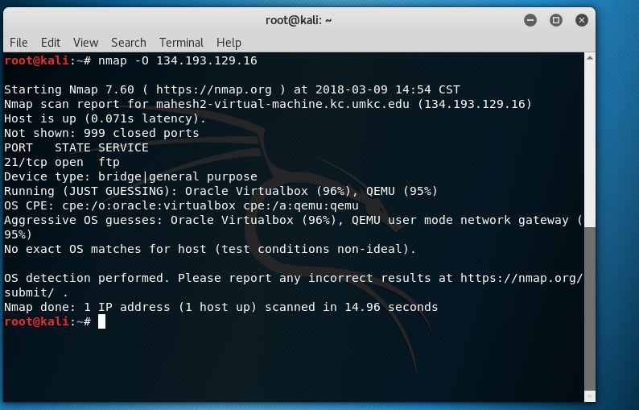

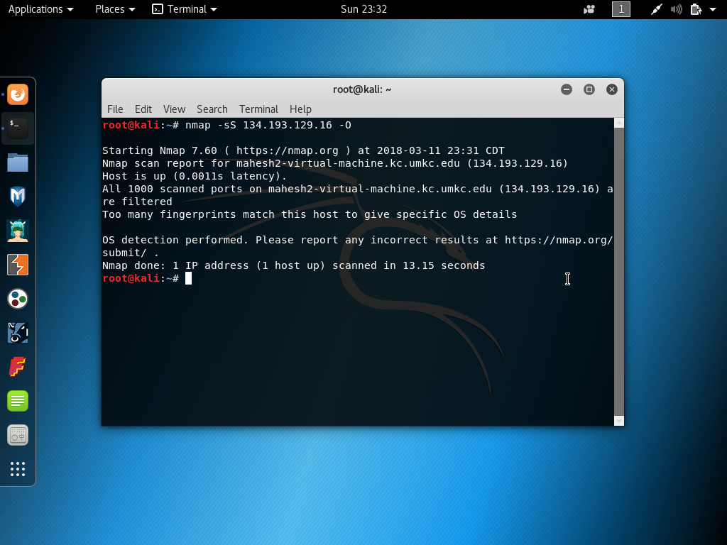

**8.** the sever uses **VSFTPD** which implies **V**ery **S**ecure **FTP** **D**aemon it uses version 3.0.2.

